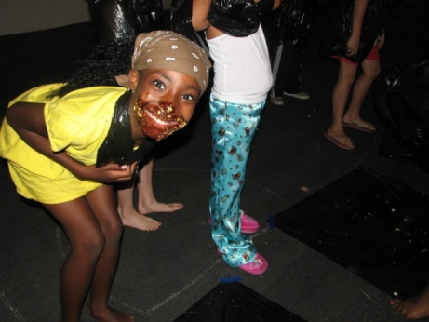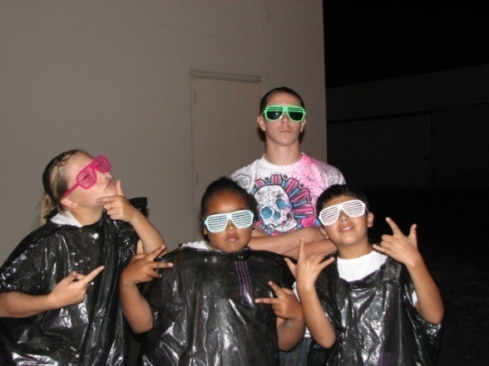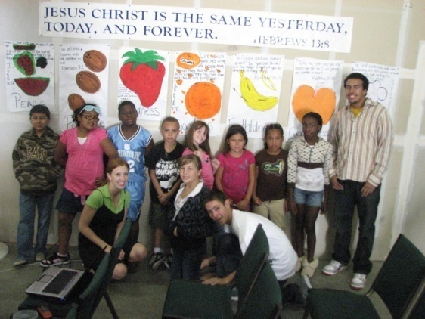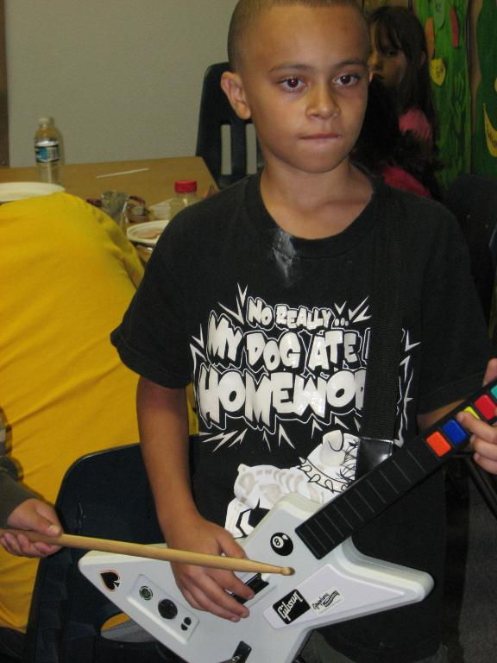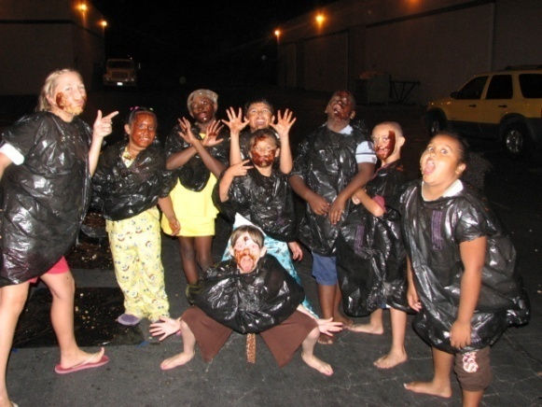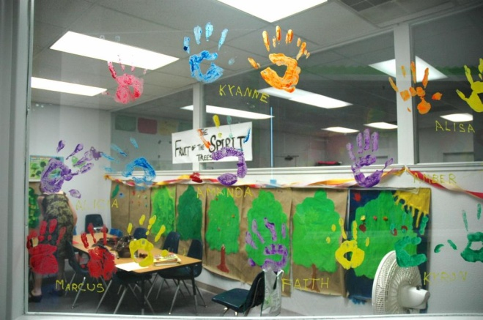

Cast roles will be assigned and all cast members will do a run through of the play.

Children’s Church

Winter 2008

Cast will work on props and sets. Cast will run though play in chronological order

Each Act will be individually blocked out and rehearsed.

November 30

December 14

December 7

##### 3rd Rehearsal

##### 2nd Rehearsal

##### Casting and 1st Rehearsal

#### Save the Date!

New Life Children’s Church is proud to present the story of the birth of Christ told with humor, mystery, and awe! Rehearsals will be held every Sunday during our normal service hours. Additional rehearsal times may be added if needed.

# Double Take! A Christmas Pageant as Told by Matthew and Luke

New Life Foursquare

1st Annual Newsletter

In order for your children to be able to participate in this years Christmas pageant it is important that they attend our regular Sunday services. Rehearsals will begin promptly at 10 am.

**If for any reason you are unable to bring your child to rehearsal, contact Pastor Amanda and we will work on alternative transportation and rehearsals.**

This play is designed to be stress free and require limited rehearsals. Encourage your children to practice their lines throughout the week so that rehearsals will go as smoothly as possible.

### Parents!

**Keep your eyes peeled for our next newsletter with more important information regarding our upcoming events!**

Contact:

Pastor Amanda

916-955-4291

On the night of the production several cast members will need makeup enhancements such as beards, wrinkles and simple stage makeup. Training will be available if you are willing to learn.

Makeup Artist

A volunteer or a team of volunteers will be needed to scrounge for needed props. Most props can be found around the church, borrowed from home or purchased at second hand stores. If you are interested in this position contact Pastor Amanda for a complete prop list.

Prop Master

# Volunteers Needed!

We will need several volunteers who are willing to pass out programs, help move sets, guide guest to their seats and jump in where needed. Volunteers will also be provided with authentic Bible time costumes to add to the atmosphere and festivity of the evening.

Crowd Control/ Usher

Your creativity is needed! The production does not have a lot of elaborate sets, so ingenuity is key. We are hoping to design some very upbeat and colorful sets that will add to the atmosphere of the production. Sets will be simple and easy to move. Talk to Pastor Amanda for more details.

## Set Designers

###### Are you a little shy on stage but still want to help with the pageant! Here are some ways you can help: